TECHNICAL PROPOSAL
ABN Platform Development
AB Intelligence and ABN+ OTT
Prepared by: Riseup Labs


1. Executive Summary
This technical proposal outlines the development approach for the ABN Platform ecosystem, consisting of AB Intelligence and ABN+ OTT. The proposal is prepared from the provided ABN platform roadmap and focuses on the required feature scope, phased development plan, architecture options, technical stack, deliverables, testing approach, and implementation remarks.
AB Intelligence is planned as an AI-driven automation, CRM, content creation, and client service platform for businesses, agencies, content creators, and enterprises. ABN+ OTT is planned as a consumer streaming platform covering VOD, live TV, live sports, subscription management, and multi-device access.
The roadmap will be implemented through the same four phases stated in the source document. The proposal does not introduce additional product features beyond the roadmap scope.

2. Roadmap Phase Plan
The phases below are kept exactly as mentioned in the provided roadmap document.
Phase | Name | Focus
Phase 1 | MVP — Market Entry | Core platform, essential features, go-live fast
Phase 2 | Growth — Scale Up | Advanced features, automation, integrations
Phase 3 | Premium — Full Vision | AI intelligence, full OTT ecosystem, apps
Phase 4 | Enterprise — Long-Term Partner | Own AI, data platform, white-label expansion

3. Platform Vision and Scope
ABN is designed as a shared digital ecosystem with two flagship platforms under one brand. Both platforms use common infrastructure where practical, while serving different user groups and business objectives.
AB Intelligence | ABN+ OTT
AI-driven platform for businesses and creators  • AI Video Generation & Editing  • Marketing Content Creation  • Workflow & CRM Automation  • 3D / Virtual Content Tools  • Client Dashboard & Admin Panel  • WhatsApp & Multi-channel CRM  • API Marketplace (Third-party AI) | Consumer streaming platform (Netflix + Live TV)  • Live TV Streaming (Multi-channel)  • Movies, Series, Originals, Documentaries  • Live Sports (Cricket, Football, Rugby…)  • Video on Demand (VOD)  • Subscription Management  • Android, iOS, Smart TV Apps  • Content Management & Admin Panel
Target: SMEs, Agencies, Content Creators, Enterprises | Target: Consumers (Bangladesh & Diaspora), Sports Fans

3.1 Shared Platform Components
The following shared components are considered for development efficiency, unified administration, and consistent user experience across both platforms.
Shared Component | Purpose
User Authentication (OTP) | Single sign-on, OTP login, user management across both platforms
Payment Gateway | bKash, Nagad, card payments, and Stripe for international coverage
Notification Engine | WhatsApp, Email, Push, SMS notifications
Admin Super Panel | Master control across both platforms from one interface
CDN & Media Infrastructure | Cloudflare / AWS CloudFront for fast video delivery globally
Analytics Engine | Cross-platform user behaviour, revenue, and content analytics

4. Technical Diagrams
The diagrams below present the proposed technical view of the ABN ecosystem. These can be replaced with final visual design diagrams during the UI/UX or solution architecture stage if required.
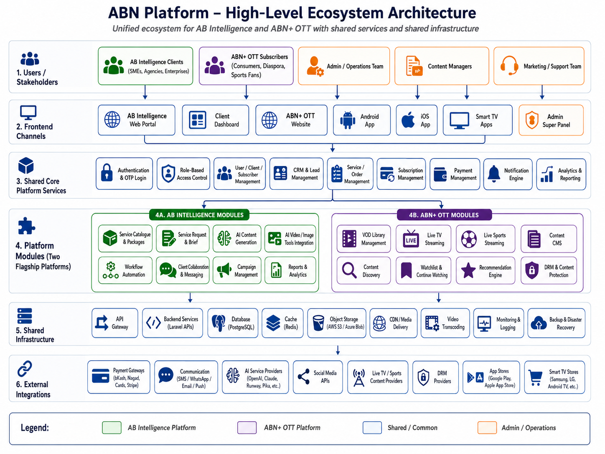
Figure 1: ABN Platform high-level ecosystem architecture
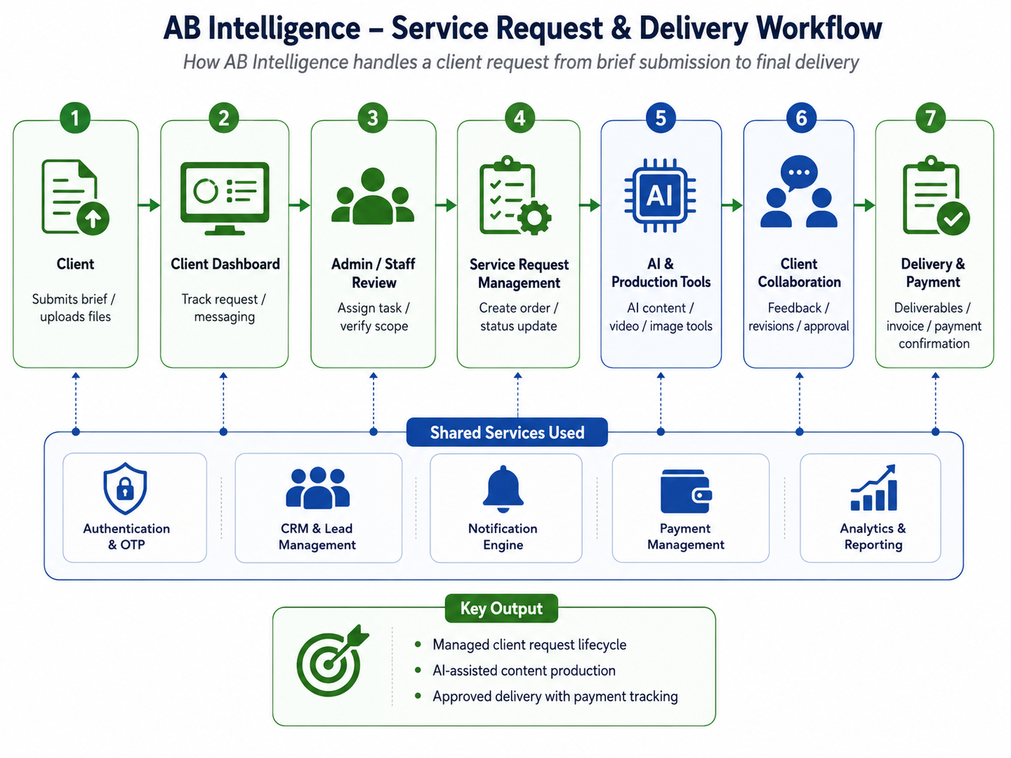
Figure 2: AB Intelligence – service request & delivery workflow

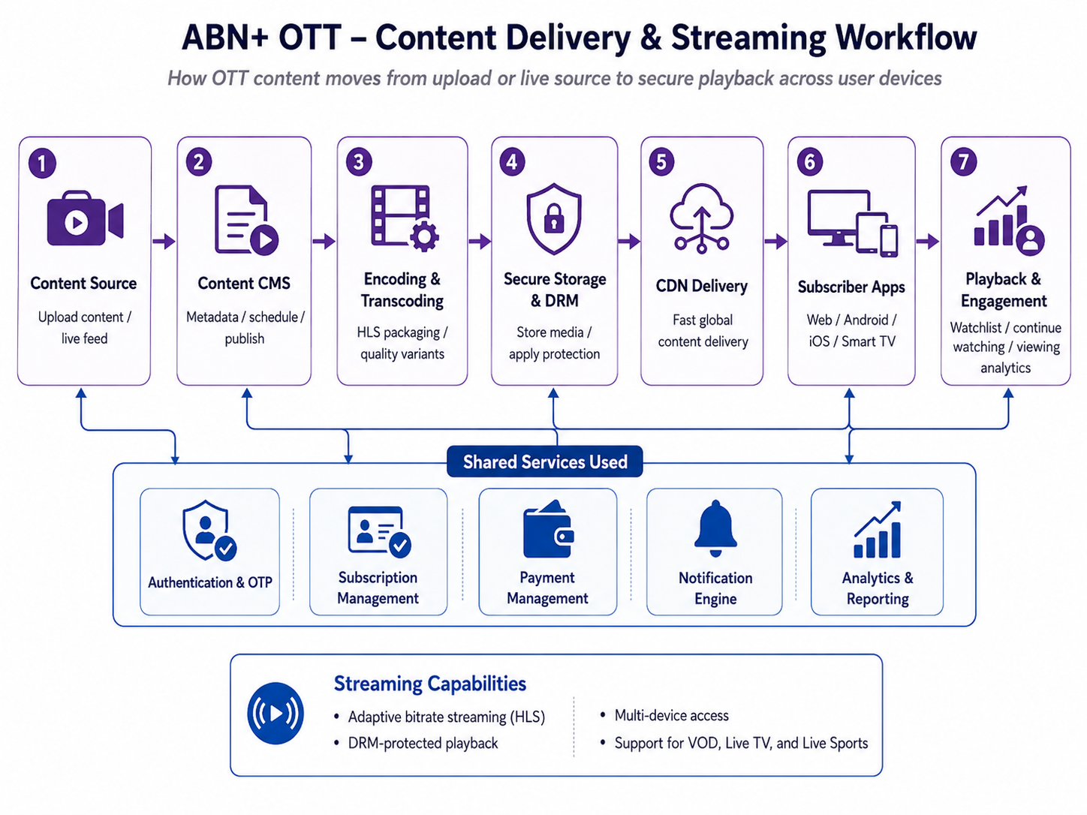
Figure 3: ABN+ OTT- content delivery and streaming workflow

5. Proposed Feature Breakdown by Phase
The features below are rewritten from the existing roadmap feature list into a purpose-and-workflow format so that each module can be understood clearly from a user and system activity perspective.

Common Infra / Shared Layer Feature Breakdown

Feature: User Authentication (OTP)
Purpose
User Authentication (OTP) provides a shared secure login foundation across AB Intelligence and ABN+ OTT so users can access the correct platform areas using verified identity and role-based permissions.
Feature Workflow
1. User opens the login or registration screen.
2. User enters mobile number or required login information.
3. The system sends OTP through the configured SMS or WhatsApp provider.
4. User verifies OTP successfully.
5. The system validates the user account and applies access rules.
6. User is redirected to the relevant dashboard, portal, or OTT experience.

Feature: Payment Gateway
Purpose
Payment Gateway provides the shared payment layer for bKash, Nagad, card payments, and Stripe so invoices, subscriptions, and paid access can be processed through approved payment methods.
Feature Workflow
1. User opens invoice, service payment, or subscription payment screen.
2. The system displays payable amount and available payment methods.
3. User selects bKash, Nagad, card, or Stripe.
4. The system processes payment through the selected gateway.
5. Payment confirmation is stored in the platform.
6. Related invoice, order, or subscription status is updated automatically.

Feature: Notification Engine
Purpose
Notification Engine provides shared SMS, WhatsApp, email, and push notification capability for platform alerts, order updates, subscription reminders, and account communication.
Feature Workflow
1. A system event occurs from CRM, order, subscription, content, or account activity.
2. The system identifies the target user and notification channel.
3. Notification message is prepared based on event type.
4. The notification is sent through SMS, WhatsApp, email, or push channel.
5. User receives the notification and opens the related item.
6. Delivery status is tracked where supported by the channel.

Feature: Admin Super Panel (Base Shell)
Purpose
Admin Super Panel provides the shared master control shell for managing core users, platform settings, shared services, and high-level administrative access across AB Intelligence and ABN+ OTT.
Feature Workflow
1. Authorized admin logs into the super admin panel.
2. The system verifies admin role and permissions.
3. Admin accesses shared configuration, user control, and platform management areas.
4. Admin updates approved settings or reviews platform activity.
5. The system stores the changes and applies them to the relevant platform modules.
6. Admin activity is tracked for operational visibility.

Feature: CDN & Media Infrastructure Setup
Purpose
CDN & Media Infrastructure setup provides the shared delivery foundation for media storage, streaming readiness, and faster content access through Cloudflare, CloudFront, or approved CDN services.
Feature Workflow
1. DevOps configures the approved storage and CDN environment.
2. Media assets or streaming outputs are connected to the delivery layer.
3. The system routes eligible media requests through the CDN.
4. Users access videos, images, or streaming content through optimized delivery paths.
5. Delivery performance and availability are monitored.
6. CDN configuration is tuned based on platform usage and traffic needs.

Feature: Analytics Engine (Base)
Purpose
Analytics Engine provides the base cross-platform tracking layer for user activity, content usage, subscription behaviour, service performance, and operational reporting.
Feature Workflow
1. Platform events are identified for approved analytics tracking.
2. The system captures activity from web, app, admin, CRM, subscription, or OTT modules.
3. Analytics data is stored and organized for reporting.
4. Admin or authorized user opens the analytics view.
5. The system displays base reports and usage indicators.
6. Insights are used for operational monitoring and future phase planning.

Feature: Auth / Login UI
Purpose
Auth / Login UI provides shared user-facing login and verification screens for consistent access experience across the ecosystem.
Feature Workflow
1. User opens the platform login page or app login screen.
2. The system displays the shared login interface.
3. User enters required login credentials or mobile number.
4. The system continues with OTP, social login, or approved authentication flow based on platform context.
5. User completes authentication successfully.
6. The system redirects the user to the correct platform area.

Phase 1 — MVP
Goal: Launch the minimum sellable product for both platforms. Acquire first paying clients. Validate the market. Build credibility.
Principle: The MVP must deliver a premium, professional experience from day one while staying focused on essential launch capabilities.

AB Intelligence — MVP Feature Breakdown

Feature: Website & Landing
Purpose
The Website & Landing feature provides a professional public entry point for AB Intelligence where visitors can understand services, review packages, submit inquiries, and start communication through lead forms or WhatsApp.
Feature Workflow
1. Visitor opens the AB Intelligence website or landing page.
2. The system displays service pages, package information, and call-to-action sections.
3. Visitor selects a service, submits a lead form, or clicks the live chat / WhatsApp button.
4. The system captures the inquiry details and stores the lead for follow-up.
5. Admin or staff reviews the lead and starts the sales or onboarding process.

Feature: User Auth & Onboarding
Purpose
User Auth & Onboarding allows Admin, Client, and Staff users to securely register, log in, and access role-specific platform areas through OTP-based authentication.
Feature Workflow
1. User opens the login or registration screen.
2. User enters mobile number and required profile information.
3. The system sends OTP through the configured SMS or WhatsApp gateway.
4. User verifies the OTP successfully.
5. The system creates or validates the account and applies the correct role-based access.
6. User is redirected to the relevant dashboard based on role.

Feature: Client Dashboard
Purpose
The Client Dashboard serves as the primary workspace where clients submit service requests, track orders, upload documents, exchange messages, and receive service-related updates.
Feature Workflow
1. Client logs into the platform.
2. The system authenticates the client and redirects to the dashboard.
3. Dashboard loads personalized account, order, request, and notification information.
4. The system displays service requests, order status, uploaded documents, messages, and notification center.
5. Client selects an action such as submit request, track order, upload document, or message the team.
6. The selected action opens the relevant workspace or form.
7. All client activities are synchronized with the admin and team workspace.

Feature: Admin Panel
Purpose
The Admin Panel enables internal users to manage clients, orders, tasks, team assignment, basic reporting, and invoice generation from one controlled interface.
Feature Workflow
1. Admin logs into the platform with authorized credentials.
2. The system verifies admin access and opens the admin panel.
3. Admin reviews clients, orders, tasks, team workload, reports, and invoice areas.
4. Admin assigns a team member or updates the task/order status.
5. The system stores the update and notifies relevant client or staff users where applicable.
6. Admin generates invoice or reviews basic operational reports as needed.

Feature: CRM / Lead Management
Purpose
CRM / Lead Management helps the team capture leads from WhatsApp and other entry points, manage contacts, move opportunities through a Kanban pipeline, and maintain follow-up reminders.
Feature Workflow
1. A lead is submitted from WhatsApp, landing page, or manual entry.
2. The system creates or updates the contact profile in CRM.
3. The lead appears in the pipeline with source, status, and contact details.
4. Staff moves the lead across Kanban stages based on progress.
5. The system triggers or stores follow-up reminders.
6. Converted leads can be connected to service requests or orders.

Feature: Service Catalogue
Purpose
The Service Catalogue presents publicly visible service packages, pricing tiers, and an order flow that allows clients to request, receive quote, approve, and proceed toward delivery.
Feature Workflow
1. Visitor or client opens the service catalogue.
2. The system displays service packages, pricing tiers, and package details.
3. User selects a service package and submits a request.
4. Admin reviews the request and prepares a quote where required.
5. Client approves the quote or selected package.
6. The approved request moves into order or delivery workflow.

Feature: Payment Integration
Purpose
Payment Integration allows clients to pay invoices and service charges online using bKash, Nagad, card payments, and Stripe while receiving payment receipts.
Feature Workflow
1. Client opens invoice or payment screen from dashboard or order flow.
2. The system displays payable amount, invoice details, and supported payment methods.
3. Client selects bKash, Nagad, card, or Stripe payment option.
4. The system redirects or processes payment through the selected gateway.
5. Payment confirmation is received and stored in the platform.
6. Client receives receipt and order/payment status is updated.

Feature: AI Tool Integrations (Basic)
Purpose
Basic AI Tool Integrations allow the platform team or authorized users to generate AI-supported video, image, and content outputs through selected third-party AI APIs such as RunwayML, Pika, OpenAI, or Claude API, based on approved roadmap scope.
Feature Workflow
1. User or staff opens the AI-supported creation area linked to a service request.
2. User provides prompt, content brief, image input, or video requirement as applicable.
3. The system sends the request to the configured third-party AI API.
4. The AI service returns generated content, image, or video output.
5. Staff reviews the output and attaches it to the relevant order or delivery workspace.
6. Client reviews the delivered output through the dashboard or communication channel.

Feature: Notifications
Purpose
The Notifications feature keeps clients, staff, and admins informed through WhatsApp notifications, email notifications, and in-app alerts for order updates and important platform activities.
Feature Workflow
1. A system event occurs such as order update, message, invoice, or task status change.
2. The system identifies the affected user and notification channel.
3. Notification content is generated based on the event type.
4. The system sends WhatsApp, email, or in-app alert as configured.
5. User receives the update and opens the related item from the notification.
6. Notification status is stored for tracking and visibility.

Feature: Mobile App (Web PWA)
Purpose
The Web PWA provides mobile-friendly access to AB Intelligence without building a native mobile app during MVP, allowing clients to use the dashboard and core workflows from mobile browsers.
Feature Workflow
1. User opens the AB Intelligence web platform on a mobile browser.
2. The system loads the responsive PWA interface.
3. User logs in and accesses dashboard, orders, messages, and notifications.
4. User can optionally add the PWA shortcut to the mobile home screen.
5. The system provides a consistent mobile experience using the same MVP web application.
6. Client activities remain synchronized with web and admin views.

ABN+ OTT — MVP Feature Breakdown

Feature: Website & Landing
Purpose
The OTT Website & Landing feature provides a public marketing site where users can view subscription plans, preview content through trailers, and understand the ABN+ OTT offering through SEO-optimized pages.
Feature Workflow
1. Visitor opens the ABN+ OTT website.
2. The system displays subscription plans, content previews, trailers, and marketing pages.
3. Visitor browses available plan information and preview content.
4. Visitor selects sign up, login, or subscription call-to-action.
5. The system redirects the user to authentication or subscription flow.
6. Visitor becomes a registered user after completing required steps.

Feature: User Auth
Purpose
User Auth allows OTT users to securely log in using OTP or social login, manage profile information, configure parental PIN, and control multi-device access.
Feature Workflow
1. User opens login or registration screen.
2. User selects OTP login or social login option.
3. The system validates the login request and creates or retrieves the user profile.
4. User configures profile information, parental PIN, or device settings where applicable.
5. The system applies user access rules and redirects to the OTT home experience.
6. Registered device and session details are managed under the account.

Feature: Subscription System
Purpose
The Subscription System manages monthly and yearly plans, free and premium tiers, auto-renewal, and discount codes to control OTT content access based on user plan status.
Feature Workflow
1. User opens the subscription plans page.
2. The system displays available monthly, yearly, free, and premium options.
3. User selects a plan and applies discount code if available.
4. The system calculates the payable amount and sends user to payment flow where required.
5. After successful payment or free-tier activation, subscription status is updated.
6. The system enables content access according to the active subscription tier.

Feature: VOD Library
Purpose
The VOD Library allows ABN+ OTT to upload, manage, and stream movies, series, documentaries, and related content using HLS adaptive streaming with resume watching and quality selection.
Feature Workflow
1. Admin uploads or manages VOD content through the CMS.
2. The system stores content metadata and prepares video for streaming.
3. User opens the OTT app or website and browses the VOD library.
4. User selects a movie, series, or documentary.
5. The player loads HLS adaptive streaming with quality selection from 480p to 1080p.
6. The system stores resume watching progress for continued viewing.

Feature: Content Management (CMS)
Purpose
The Content Management System enables authorized admins to upload content, define metadata, set licensing information, manage categories, schedule releases, and publish or unpublish titles.
Feature Workflow
1. Admin logs into the CMS using authorized access.
2. Admin uploads content file and enters title, category, artwork, licensing, and release information.
3. The system validates required metadata and stores the content record.
4. Admin schedules release or changes publication status.
5. The system publishes or unpublishes content based on approval and schedule.
6. Published content becomes available to eligible users in the OTT interface.

Feature: Payment Gateway
Purpose
The OTT Payment Gateway supports bKash, Nagad, Visa/Mastercard, Stripe, subscription billing, and payment history for paid plans and renewal workflows.
Feature Workflow
1. User selects a paid subscription plan or renewal option.
2. The system displays payable amount and available gateway options.
3. User selects bKash, Nagad, Visa/Mastercard, or Stripe as the payment method.
4. Payment is processed through the selected gateway.
5. The system records payment status and updates subscription validity.
6. User can view payment history from account area.

Feature: Basic Live TV
Purpose
Basic Live TV allows ABN+ OTT to stream 2–5 licensed live channels using HLS live stream player and a basic Electronic Programme Guide.
Feature Workflow
1. Admin configures licensed live channel source and EPG information.
2. User opens the Live TV section.
3. The system displays available channels and basic programme guide.
4. User selects a live channel.
5. The HLS live stream player loads the selected stream.
6. User watches the live channel within the OTT interface.

Feature: Android App
Purpose
The Android App provides native access for phone and tablet users, enabling ABN+ OTT login, browsing, subscription access, and video playback with DRM-ready support.
Feature Workflow
1. User installs the ABN+ OTT Android app from Google Play Store after publication.
2. User logs in through the configured authentication method.
3. The app loads home, discovery, subscription, and content sections.
4. User selects VOD or live content.
5. The app plays content using supported video playback and DRM-ready configuration.
6. Viewing progress and account actions are synchronized with backend services.

Feature: Content Discovery
Purpose
Content Discovery helps users find relevant OTT content through search, genre filtering, trending section, recently added content, and watchlist functionality.
Feature Workflow
1. User opens the OTT home or discovery section.
2. The system displays search, genre filters, trending items, recently added titles, and watchlist access.
3. User searches, filters by genre, or opens a listed content section.
4. The system returns matching titles based on selected criteria.
5. User selects a title to view details or play content.
6. User can add the title to Watchlist / My List for later viewing.

Feature: Notifications
Purpose
OTT Notifications inform users about new content, subscription expiry, Android push alerts, and email-based updates related to their account and viewing experience.
Feature Workflow
1. A content, subscription, or account event occurs.
2. The system identifies the users who should receive the notification.
3. Notification content is prepared for push or email channel.
4. The system sends new content alert, subscription expiry reminder, or account update.
5. User opens the notification and is redirected to the related screen.
6. The system records notification delivery status where applicable.

Phase 2 — Growth
Goal: Expand platform capabilities based on real user feedback. Add automation, advanced AI features, iOS app, and live sports streaming. Begin monetizing at scale.

AB Intelligence — Phase 2 Feature Breakdown

Feature: Workflow Automation Builder
Purpose
Workflow Automation Builder enables clients to create visual drag-and-drop automation flows through approved automation tools and API integrations such as n8n or Make.com.
Feature Workflow
1. Client opens the automation builder from the dashboard.
2. The system displays available workflow templates, triggers, and actions.
3. Client creates or edits a workflow using drag-and-drop steps.
4. Client connects required app or API credentials where applicable.
5. The system validates the workflow and saves it.
6. Workflow runs based on configured trigger and logs execution status.

Feature: AI Video Studio
Purpose
AI Video Studio expands AI video capabilities with avatar creation, voiceover, script-to-video, and multi-language video support.
Feature Workflow
1. User opens AI Video Studio.
2. User selects video type such as avatar, voiceover, or script-to-video.
3. User uploads script, media, language preference, or required input.
4. The system sends the request to the configured AI video services.
5. Generated output is returned for preview.
6. User or staff reviews, revises, and saves the output for delivery or publishing.

Feature: 3D & Virtual Content Tools
Purpose
3D & Virtual Content Tools support product visualization, virtual property tours, and rendering workflows through approved 3D rendering APIs.
Feature Workflow
1. User opens the 3D or virtual content request area.
2. User uploads required product, property, or visualization assets.
3. The system sends eligible inputs to the configured 3D rendering API.
4. Generated preview or rendering output is returned to the workspace.
5. Staff reviews the output and requests revision if required.
6. Final output is shared with the client through the project/order workspace.

Feature: Advanced CRM
Purpose
Advanced CRM strengthens pipeline management with automated follow-ups, WhatsApp sequences, and email drip campaigns.
Feature Workflow
1. Staff opens the CRM pipeline.
2. The system displays leads, contacts, stages, follow-up status, and communication history.
3. Staff configures automated follow-up, WhatsApp sequence, or email drip campaign.
4. The system sends communications based on defined triggers and timing.
5. Lead responses and activities are recorded in CRM.
6. Staff updates lead stage or converts lead into service opportunity.

Feature: Multi-platform Social Publishing
Purpose
Multi-platform Social Publishing allows clients or staff to schedule and publish content to Instagram, Facebook, YouTube, and TikTok from the dashboard.
Feature Workflow
1. User opens the social publishing module.
2. User connects approved social media accounts where applicable.
3. User uploads or selects content and prepares caption, platform, and schedule.
4. The system validates platform-specific publishing requirements.
5. Content is scheduled or published to selected channels.
6. Publishing status and performance data are displayed in the dashboard when available.

Feature: Team Collaboration
Purpose
Team Collaboration supports internal task management, client approval workflows, comments, and revision tracking for service delivery.
Feature Workflow
1. Admin or staff opens an order or project workspace.
2. The system displays assigned tasks, comments, approval status, and revision history.
3. Team member updates task progress or submits work for review.
4. Client or authorized reviewer adds comments or approval decision.
5. The system records revision and approval history.
6. Approved work moves to delivery or completion status.

Feature: Analytics & Reporting
Purpose
Analytics & Reporting provides client-facing reports covering content performance, campaign ROI, and platform usage statistics.
Feature Workflow
1. Client or staff opens the reporting area.
2. The system loads available content, campaign, and usage data.
3. User selects date range, project, campaign, or report type.
4. The system generates the report view.
5. User reviews metrics, charts, and summaries.
6. Report can be exported or shared where supported by the approved scope.

Feature: iOS App (Native)
Purpose
The native iOS app provides App Store access for AB Intelligence users with mobile-optimized access to approved dashboard and service workflows.
Feature Workflow
1. User installs the iOS app after App Store publication.
2. User logs in using approved authentication flow.
3. The app loads dashboard, projects, messages, notifications, and available service features.
4. User performs service request, review, message, or notification actions.
5. The system synchronizes app activity with the backend.
6. User receives mobile updates through supported channels.

Feature: White-label Option
Purpose
White-label Option allows resellers or agencies to run ABN Intelligence under their own brand based on approved branding and reseller configuration.
Feature Workflow
1. Admin opens white-label configuration for an approved reseller or agency.
2. Admin sets brand name, logo, domain, and visual identity settings where applicable.
3. The system applies branding to the reseller-facing experience.
4. Reseller users access the branded portal.
5. Clients interact with the platform under reseller branding.
6. Admin monitors usage and configuration from the master platform controls.

ABN+ OTT — Phase 2 Feature Breakdown

Feature: iOS App (Native)
Purpose
The native iOS app provides App Store access to ABN+ OTT with iOS-optimized user experience and AirPlay support.
Feature Workflow
1. User installs the iOS app after App Store publication.
2. User logs in or registers using the supported authentication flow.
3. The app loads home, discovery, subscription, and content areas.
4. User selects VOD or live content.
5. The app plays content with iOS-optimized playback and AirPlay support.
6. Viewing progress and subscription access are synchronized with backend services.

Feature: Smart TV Apps
Purpose
Smart TV Apps extend ABN+ OTT to Android TV, Fire Stick, Nvidia Shield, and Samsung Tizen as defined in the phase roadmap.
Feature Workflow
1. User installs the supported smart TV app.
2. User signs in through the TV login flow.
3. The app loads TV-optimized navigation, content categories, and playback screens.
4. User selects VOD or live content using remote-friendly controls.
5. The system validates subscription and playback eligibility.
6. Content plays through the supported smart TV streaming player.

Feature: Expanded Live TV
Purpose
Expanded Live TV increases channel capacity to 10–20 channels and introduces fuller EPG, channel guide, and show reminder support.
Feature Workflow
1. Admin configures additional licensed live channels and EPG data.
2. User opens the Live TV channel guide.
3. The system displays channels, schedule, and programme information.
4. User selects a channel or sets reminder for a show.
5. The system stores reminder preference and sends alert where configured.
6. User opens the channel and watches the live stream.

Feature: Live Sports Module
Purpose
Live Sports Module provides a dedicated sports section with live match tracker, score overlay, and future-ready multi-camera support.
Feature Workflow
1. User opens the Sports section.
2. The system displays available live or upcoming sports events.
3. User selects a match or event.
4. The system loads live stream with match tracker or score overlay where available.
5. User watches the match within the OTT player.
6. Event status and metadata are updated from configured sources.

Feature: 4K / HDR Streaming
Purpose
4K / HDR Streaming enables premium-tier users to access higher-quality content on supported devices and network conditions.
Feature Workflow
1. Admin marks eligible content as available in 4K or HDR quality.
2. Premium user opens eligible content on a supported device.
3. The system checks subscription tier, device capability, and available stream quality.
4. The player selects appropriate stream quality based on settings and bandwidth.
5. User watches content in 4K or HDR where supported.
6. Playback quality changes automatically if network conditions require adaptation.

Feature: Recommendation Engine
Purpose
Recommendation Engine suggests content to users based on watch history and preferences to improve content discovery.
Feature Workflow
1. User watches, searches, or adds content to watchlist.
2. The system records viewing and preference signals.
3. Recommendation logic processes available user activity and content metadata.
4. The OTT home screen displays recommended titles.
5. User selects recommended content for details or playback.
6. Future recommendations are updated based on continued activity.

Feature: Download for Offline
Purpose
Download for Offline allows premium users to save DRM-protected content for offline viewing on supported devices.
Feature Workflow
1. Premium user opens an eligible content detail page.
2. User taps the download option.
3. The system checks subscription, device, and DRM eligibility.
4. Content is downloaded securely to the device.
5. User opens the downloaded item without active streaming connection.
6. The system enforces availability and DRM rules for offline playback.

Feature: Chromecast / AirPlay
Purpose
Chromecast / AirPlay allows users to cast content from mobile devices to supported TVs or screens.
Feature Workflow
1. User opens content on the mobile app.
2. The app detects supported Chromecast or AirPlay devices on the same environment.
3. User selects the casting device.
4. The system establishes casting session and validates playback access.
5. Content plays on the selected screen while controls remain on mobile.
6. User can pause, resume, or stop casting from the app.

Phase 3 — Premium Full Vision
Goal: Deliver the complete vision. Full AI intelligence layer, complete OTT ecosystem, live event infrastructure, and advanced business automation as defined in the module-level roadmap.

AB Intelligence — Phase 3 Feature Breakdown

Feature: AI Intelligence Layer
Purpose
AI Intelligence Layer introduces ABN-specific custom AI capabilities including brand voice learning and AI quality review based on approved model strategy.
Feature Workflow
1. Admin configures brand voice, content examples, and AI quality rules.
2. User submits content or campaign requirement.
3. The AI intelligence layer applies configured brand context and review logic.
4. The system generates or evaluates output against quality rules.
5. Staff reviews the AI-assisted result.
6. Approved output is delivered or reused in future workflows.

Feature: Self-serve AI Studio
Purpose
Self-serve AI Studio allows clients to create AI workflows using templates without direct team assistance.
Feature Workflow
1. Client opens Self-serve AI Studio.
2. The system displays available templates and workflow options.
3. Client selects a template and provides required inputs.
4. The system generates content or workflow output based on selected template.
5. Client reviews, edits, or regenerates output.
6. Final output is saved, downloaded, or moved into project workflow.

Feature: API Marketplace
Purpose
API Marketplace provides a curated list of third-party AI tools that can be browsed and activated from within the ABN dashboard.
Feature Workflow
1. User opens API Marketplace from the dashboard.
2. The system displays available third-party AI tools and descriptions.
3. User selects a tool and reviews activation requirements.
4. Admin or authorized user activates the tool where permitted.
5. The system connects the activated API to the relevant workspace.
6. User can access the tool according to configured permissions and usage limits.

Feature: Advanced Analytics Dashboard
Purpose
Advanced Analytics Dashboard adds predictive analytics, campaign ROI forecasting, and content performance benchmarking for business decision-making.
Feature Workflow
1. User opens advanced analytics from dashboard.
2. The system loads available campaign, content, usage, and performance data.
3. User selects forecast, benchmark, or ROI analysis view.
4. The system processes data and displays predictive or comparative insights.
5. User reviews insights and identifies improvement actions.
6. Reports can support campaign planning and management review.

Feature: Reseller / Agency Portal
Purpose
Reseller / Agency Portal provides full white-label capabilities with custom domain, branding, and client billing management for agency partners.
Feature Workflow
1. Admin creates a reseller or agency account.
2. Admin configures custom domain, branding, and billing settings.
3. Agency logs into the reseller portal.
4. Agency manages its client accounts and service workflows.
5. The system tracks agency-level usage, billing, and client activity.
6. Master admin monitors reseller performance from the central platform.

Feature: Enterprise Tier
Purpose
Enterprise Tier supports large clients with custom SLAs, dedicated account manager, priority support, and custom integrations as defined per enterprise agreement.
Feature Workflow
1. Admin creates or upgrades an enterprise client account.
2. The system applies enterprise-level service settings and access rules.
3. Dedicated account manager or support team is assigned.
4. Enterprise user submits requests or integration requirements.
5. The team manages priority handling according to configured SLA.
6. Enterprise activity and service performance are tracked for reporting.

ABN+ OTT — Phase 3 Feature Breakdown

Feature: Live Event Infrastructure
Purpose
Live Event Infrastructure enables scalable support for major live events using ingestion, CDN burst capacity, and event-ready streaming operations.
Feature Workflow
1. Admin configures live event source, schedule, metadata, and access settings.
2. The system prepares ingestion and CDN delivery configuration.
3. User opens the live event page before or during the event.
4. The player connects to the live event stream.
5. The platform monitors load and playback readiness.
6. Event replay or recorded content can be managed after the event where scoped.

Feature: 8K Streaming Support
Purpose
8K Streaming Support future-proofs premium smart TV playback for eligible content, supported devices, and suitable network conditions.
Feature Workflow
1. Admin marks eligible premium content for 8K processing where source quality is available.
2. The system prepares appropriate high-resolution streaming assets.
3. User opens eligible content on a supported smart TV.
4. The system checks device capability, subscription tier, and bandwidth.
5. The player selects 8K stream when all conditions are satisfied.
6. Playback adapts to lower quality if required for continuity.

Feature: ABN Originals Production Pipeline
Purpose
ABN Originals Production Pipeline manages ABN-produced original content workflows, including production process tracking and rights management information.
Feature Workflow
1. Content team creates an original content record.
2. The system stores production details, rights information, and workflow status.
3. Team updates production stages and related assets.
4. Admin reviews readiness for publishing or further processing.
5. Approved content is moved toward CMS publishing workflow.
6. Rights and production metadata remain available for operational tracking.

Feature: Local Sports (Community Events)
Purpose
Local Sports supports community tournaments, cultural events, Kabaddi, and similar local content as live or recorded OTT programming.
Feature Workflow
1. Content team creates a local sports or community event entry.
2. Admin adds event metadata, schedule, stream source, and access settings.
3. User opens the local sports or community event section.
4. The system displays live or recorded event options.
5. User selects an event to watch.
6. The platform delivers the event as live stream or VOD based on availability.

Feature: Advanced Recommendation AI
Purpose
Advanced Recommendation AI improves personalization with ML-powered content recommendations similar to modern OTT platforms.
Feature Workflow
1. The system collects eligible viewing, preference, and content metadata signals.
2. Recommendation AI processes user behavior and content relationships.
3. Personalized recommendations are generated for each user or profile.
4. The OTT interface displays recommended rows or sections.
5. User interacts with recommended content.
6. The AI model updates future recommendations based on ongoing behavior.

Feature: Multi-region CDN
Purpose
Multi-region CDN improves streaming performance for diaspora audiences by using optimized CDN nodes in regions such as UK, Australia, and Middle East.
Feature Workflow
1. Admin or DevOps configures regional CDN distribution strategy.
2. The system routes video delivery through optimized CDN endpoints.
3. User opens ABN+ OTT from a supported international region.
4. The platform serves content from the nearest or best-performing CDN path.
5. Playback quality and delivery performance are monitored.
6. CDN configuration can be tuned based on traffic and performance data.

Feature: B2B Streaming API
Purpose
B2B Streaming API allows corporate clients to embed ABN+ streams in approved third-party applications or digital properties.
Feature Workflow
1. Admin creates a B2B client and API access configuration.
2. The system generates API credentials and usage rules.
3. Corporate client integrates the streaming API into its own app or platform.
4. The API validates access and returns approved stream or content data.
5. End users consume embedded ABN+ streams through the partner platform.
6. Usage and access logs are monitored through admin controls.

Phase 4 — Enterprise & Long-Term
Goal: Retain Phase 4 as a long-term roadmap marker only. Detailed module-level scope should be finalized later because the provided PDF module-level breakdown does not define Phase 4 features.

Phase 4 Module-Level Alignment Note
The uploaded PDF module-level breakdown does not define separate Phase 4 feature modules. Therefore, no detailed Phase 4 feature workflow is included in this proposal. Phase 4 should remain a long-term roadmap marker only and should be detailed later after separate confirmation and scope approval.

6. Proposed Technical Approach
The solution will be developed as a shared ecosystem that supports two platform lines while reusing common modules such as authentication, payment, notifications, analytics, admin control, CDN/media infrastructure, and user management.

6.1 Application Layer
- Web portals will be developed using React.js / Next.js for marketing pages, dashboards, admin panels, and CMS interfaces.
- Mobile delivery will start with PWA support where stated in the MVP and expand to native/cross-platform mobile apps based on the roadmap phase.
- OTT playback interfaces will use HLS-compatible players with DRM-ready playback support for protected content.
- Smart TV apps will be implemented in the roadmap phases where they are explicitly included.

6.2 Backend and API Layer
- Laravel will be used for backend APIs, business logic, role-based access, admin operations, CRM/order management, subscription handling, CMS, and shared services.
- The backend will expose secure REST APIs for web, mobile, and TV clients.
- Queue-based processing will be used for long-running jobs such as notifications, content processing triggers, media workflows, and reporting tasks.
- Redis will support caching, session-related optimization, and background job processing where required.

6.3 Media, Streaming, and OTT Layer
- VOD content will be uploaded through CMS, processed through the media pipeline, stored securely, and delivered through CDN-backed streaming.
- HLS adaptive streaming will support quality selection and reliable playback across supported devices.
- DRM configuration will be considered for protected video playback, especially for Android, iOS, and smart TV apps.
- Live TV and live sports will depend on licensed source streams and streaming ingestion readiness.

6.4 AI and Automation Layer
- AI integrations will initially use third-party AI APIs specified in the roadmap for video, image, and content generation features.
- Workflow automation and CRM automation will be integrated through the approved automation tools and API services during the relevant phases.
- Advanced AI model tuning or proprietary AI will be considered only in the later phases where it is explicitly listed.

6.5 Security and Access Control
- JWT-based authentication and OTP-based login will be used as stated in the roadmap.
- Role-based access control will cover Admin, Client, Staff, and other roles required by the roadmap features.
- Payment, user, subscription, and content management areas will be protected through authorization checks, audit logging, input validation, and secure API design.
- Security testing will be included before production release of each applicable phase.

7. Development Approach Options
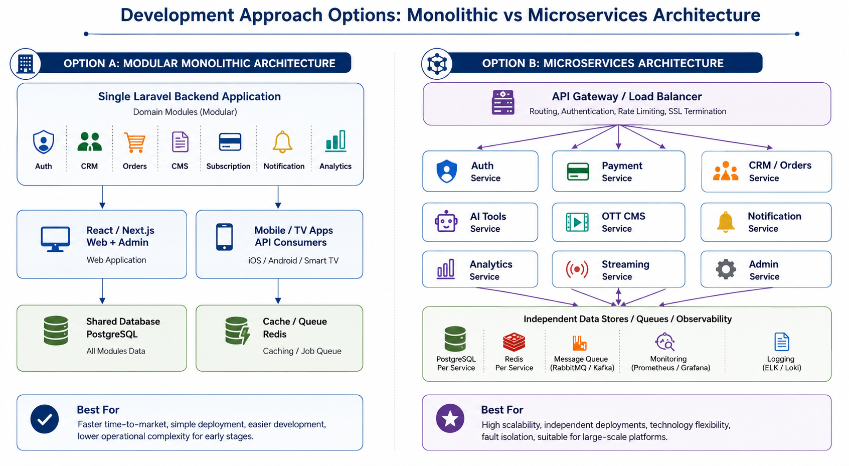
Figure 3: Monolithic and Microservices architecture options

7.1 Approach A — Monolithic Architecture
In the monolithic approach, the ABN backend is developed as a single Laravel application with modular domains inside one codebase. Modules such as authentication, CRM, order management, CMS, payment, notification, subscription, analytics, and admin panel operate within one backend application and share common infrastructure.

How the System Will Be Developed
- Create a modular Laravel backend with clear domain folders and service classes for each platform area.
- Build a shared database schema in PostgreSQL with Redis for cache and queues.
- Expose APIs for React/Next.js web portals, PWA, mobile apps, and OTT clients.
- Integrate payment, SMS/WhatsApp, AI APIs, media pipeline, CDN, and DRM based on the roadmap phase.
- Deploy the application as a single backend release with controlled module-level development and regression testing.

Advantages
- Faster MVP delivery and lower implementation complexity.
- Simpler deployment, debugging, and team coordination.
- Good fit for Phase 1 where the priority is market entry and validation.
- Shared modules can be reused efficiently without service-to-service communication overhead.

Limitations
- Scaling is usually performed for the whole application, not individual modules.
- Large codebase can become harder to maintain as AB Intelligence and ABN+ OTT grow.
- A major issue in one module can affect the overall backend if isolation is not carefully managed.
- Independent deployment of individual business domains is limited.

7.2 Approach B — Microservices Architecture
In the microservices approach, the ABN platform is developed as multiple independent services grouped by business capability. Example service domains include authentication, subscription and payment, OTT CMS, streaming, AI integrations, CRM/order management, notification, analytics, and admin operations. These services communicate through APIs and asynchronous queues/events.

How the System Will Be Developed
- Define service boundaries for core domains such as Auth, Payment, OTT CMS, Streaming, AI Tools, CRM/Orders, Notifications, and Analytics.
- Develop each service with its own API contract, deployment process, and database or data ownership model where required.
- Use an API gateway or load balancer to route frontend/mobile/TV requests to the correct services.
- Use queues/events for asynchronous tasks such as notification delivery, subscription updates, media processing status, and analytics events.
- Apply independent CI/CD, monitoring, logging, and failure isolation for each service.

Advantages
- Independent scaling for high-load services such as streaming, notification, subscription, analytics, or AI integrations.
- Better long-term maintainability when teams grow and platform traffic increases.
- Service isolation reduces the risk of one module affecting the full system.
- Supports enterprise-level expansion, white-label, and high-traffic live event scenarios.

Limitations
- Higher initial development and DevOps complexity compared with a monolith.
- Requires stronger API governance, monitoring, logging, deployment automation, and service ownership.
- More complex debugging due to distributed service communication.
- May slow down Phase 1 if used before product-market validation and final scope locking.

7.3 Key Differences
Area | Monolithic Architecture | Microservices Architecture
Codebase | Single Laravel backend with internal modules | Separate services by domain capability
Deployment | One backend release package | Independent service deployments
Scaling | Scale the full backend together | Scale individual high-load services independently
Complexity | Lower initial complexity | Higher engineering and DevOps complexity
Best Fit | Phase 1 MVP and controlled launch | High-scale growth, enterprise expansion, live event loads
Risk | Module issue may affect shared backend | Service failure can be isolated with proper design
Cost/Effort Impact | Lower initial engineering effort | Higher initial engineering effort and operational overhead

8. Proposed Technical Stack
Layer | Preferred Technology | Usage
Frontend Web | React.js / Next.js | Marketing websites, dashboards, admin interfaces, SEO-friendly public pages
Backend | Laravel | API layer, business logic, RBAC, CMS, CRM/order management, subscription/payment workflows
Mobile | PWA for MVP; Flutter or native apps based on phase scope | Mobile user access for client portal and OTT applications
Database | PostgreSQL | Core relational data for users, subscriptions, orders, content metadata, CRM, and analytics summaries
Cache / Queue | Redis | Caching, background jobs, notification queues, performance optimization
Media Processing | AWS MediaConvert or equivalent approved media service | Video transcoding and adaptive streaming preparation
Storage / CDN | S3-compatible storage + CloudFront/CDN | Secure media storage and global content delivery
Streaming | HLS + Shaka Player / Video.js | Adaptive video streaming and DRM-ready playback
DRM | Widevine + FairPlay | Protected OTT playback for supported Android, browser, iOS, and TV environments
Cloud | Azure primary or AWS, based on final infrastructure decision | Hosting, scaling, monitoring, backup, deployment environment
Authentication | JWT + OTP via SMS/WhatsApp provider | Secure login and session handling
Payment | SSLCommerz / ShurjoPay + Stripe for international coverage | Subscription and invoice payment processing
Notifications | Email, SMS, WhatsApp, Push | Order updates, subscription alerts, content alerts, and system notifications
DevOps | CI/CD pipeline, environment separation, monitoring | Controlled deployment, release management, logging, and operational visibility

9. Development Methodology
The project will follow an Agile development methodology with phased delivery. Each phase will be broken down into planned sprints covering requirement refinement, UI/UX, development, integration, QA, release preparation, and deployment support.
Stage | Activity | Output
Requirement Finalization | Review the roadmap, confirm phase scope, define acceptance criteria, and finalize dependencies. | Approved requirement baseline for the phase
UI/UX Design | Prepare information architecture, key screens, design system, and clickable prototype where applicable. | Approved UI/UX design and design system
Sprint Planning | Break approved requirements into sprint backlog and technical tasks. | Sprint plan and delivery milestones
Development | Implement frontend, backend, mobile/TV clients, integrations, and admin/CMS modules as per phase scope. | Working modules and APIs
Integration | Connect payment, OTP, AI APIs, media pipeline, CDN, DRM, notifications, and analytics where required. | Integrated platform build
Testing & QA | Perform functional, integration, performance, security, compatibility, and regression testing. | QA report and issue tracker
Release & Deployment | Prepare production build, environment setup, data migration where required, and release checklist. | Deployed phase release
Handover | Provide documentation, admin training, source code handover, and operational guidance. | Handover package

10. Deliverables
Category | Deliverables
Project Documentation | Requirement clarification notes, sprint plan, implementation plan, release checklist, handover document
UI/UX | Design system, responsive web designs, dashboard designs, admin/CMS designs, mobile/TV screen designs based on phase scope
Frontend | AB Intelligence web portal, ABN+ OTT web portal, landing pages, dashboards, CMS/admin interfaces
Backend & APIs | Laravel backend APIs, authentication, RBAC, CRM/order modules, subscription/payment modules, CMS, notification, analytics
AI & Automation | AI API integrations, automation workflow integration, CRM automation features as included in the phase roadmap
OTT & Media | VOD library, HLS video player, live TV support, media processing pipeline, DRM-ready playback, CDN integration
Mobile & TV Apps | PWA, Android, iOS, Android TV, Fire Stick, Nvidia Shield, and Samsung Tizen apps only in the roadmap phases where they are included
Cloud & DevOps | Development/staging/production environment setup, CI/CD pipeline, monitoring/logging baseline, backup configuration
Testing | Test cases, QA execution report, bug fixing support, performance/security/compatibility test summary
Deployment & Handover | Production deployment, admin orientation, technical handover, source code/package handover

11. Testing and Quality Assurance
QA Area | Coverage
Functional Testing | Validate user registration, OTP login, dashboards, service requests, order tracking, CRM, CMS, subscription, payment, notifications, and admin workflows.
API Testing | Verify authentication, authorization, request/response validation, error handling, rate limits, and integration endpoints.
Integration Testing | Validate payment gateway, SMS/WhatsApp, AI APIs, media pipeline, CDN, DRM, social login, and app notification flows.
OTT Playback Testing | Validate HLS streaming, adaptive quality, resume watching, watchlist, multi-device playback, DRM-ready playback, and live TV/channel playback where applicable.
Performance Testing | Check dashboard response time, API response time, concurrent playback behavior, CDN delivery behavior, and high-traffic readiness for live features.
Security Testing | Check authentication, RBAC, session management, input validation, payment workflow protection, secure storage access, and OWASP-focused web/API risks.
Compatibility Testing | Verify responsive web behavior, Android/iOS compatibility, supported browser playback, and smart TV app compatibility by phase scope.
Regression Testing | Run regression testing before each release to ensure previously approved modules remain stable.
Release Verification | Verify production configuration, environment variables, analytics, monitoring, backup, and rollback readiness before launch.

12. Remarks and Assumptions
Area | Remarks
Scope Consideration | The proposed scope is limited to the features listed under the roadmap phases in this proposal. Any additional backlog item, new module, or change outside the approved phase scope should be handled through a formal change request.
Estimate Consideration | The roadmap targets are considered as phase-level implementation estimates: Months 1-4, Months 5-9, Months 10-15, and Month 16+. These estimates assume timely approval, clear feedback, and availability of required third-party accounts and content assets. No financial estimate is included.
Architecture Consideration | Both monolithic and microservices approaches are included for decision-making. The proposal does not assume that both approaches will be built simultaneously. The final architecture should be agreed before detailed sprint planning.
Technical Dependencies | Payment gateway onboarding, SMS/WhatsApp provider, AI API accounts, cloud subscription, CDN setup, DRM provider readiness, app store accounts, DNS, email service, and analytics tools must be available as per implementation needs.
OTT Content Dependencies | VOD content, trailers, metadata, content licensing, geo-rights, live TV source feeds, live sports rights, EPG data, and content artwork must be provided or approved by ABN or its content partners.
AI Dependencies | AI video, image, voice, and content generation features depend on selected third-party AI API availability, usage limits, policy constraints, output quality, and commercial access terms.
Security and Compliance | Security controls will be implemented technically, but final legal, licensing, broadcasting, copyright, tax, data protection, and regulatory compliance responsibilities must be confirmed by ABN and relevant advisors.
Data Migration | No legacy data migration is assumed unless existing users, content, subscriptions, or CRM data are provided and scoped separately.
Infrastructure | Cloud infrastructure will be configured based on the final selected provider and environment plan. High-traffic live event scaling requires earlier load planning, CDN configuration, and source stream validation.
Maintenance | Post-launch maintenance, AMC, retainer support, and managed services can be scoped separately after each phase release if required.
Exclusions | Financial terms, licensing fees, content acquisition costs, marketing campaign execution costs, third-party API usage costs, cloud consumption charges, hardware procurement, and legal advisory are not included in this technical proposal.

13. Out of Scope
The following items are not included within the proposed development scope unless separately agreed, planned, and approved in a future phase or separate engagement:
- Content production for ABN+ OTT, including movies, series, originals, documentaries, sports content, video shooting, editing, dubbing, and post-production.
- Content licensing, broadcasting rights negotiation, live TV channel agreements, sports rights acquisition, and legal clearance for media distribution.
- Procurement of third-party tools, cloud subscriptions, AI API credits, DRM licenses, app store developer accounts, payment gateway accounts, SMS/WhatsApp gateway accounts, or CDN usage costs.
- Custom proprietary AI model development in the initial phases unless specifically planned under the later enterprise roadmap.
- Features not listed under the defined ABN Platform roadmap phases, including additional modules, advanced automation, marketplace features, advertising platform, or white-label SaaS expansion unless included in the relevant approved phase.
- Hardware, studio setup, camera equipment, production equipment, smart TV testing devices, server hardware, or physical infrastructure procurement.
- Digital marketing execution, paid ad campaigns, SEO operations, social media management, and subscriber acquisition activities.
- Legal, regulatory, tax, compliance certification, copyright, and data privacy consulting beyond standard technical security best practices.
- Migration of legacy systems, historical databases, or existing third-party platform data unless separately assessed and scoped.
- 24/7 production support, AMC, cloud operations, cybersecurity retainer, and long-term maintenance unless covered under a separate support or maintenance agreement.
- Any change request, enhancement, or feature expansion outside the approved phase scope and agreed roadmap.
14. Conclusion
The ABN Platform roadmap can be delivered as a phased ecosystem covering AB Intelligence and ABN+ OTT while maintaining shared infrastructure for authentication, payments, notifications, analytics, admin control, and media delivery. The proposal keeps the roadmap phases intact, presents both monolithic and microservices development approaches, and defines the required technical stack, deliverables, QA coverage, and implementation remarks for transparent planning.
The final architecture decision should be confirmed before detailed sprint planning so the team can align development, DevOps, integrations, testing, and release activities with the selected approach and phase goals.

